**DAILY ONLINE ACTIVITIES SUMMARY**

|  |  |  |  |  |  |  |  |  |
| --- | --- | --- | --- | --- | --- | --- | --- | --- |
| **Date:** | **15/07/2020** | | | | | **Name:** | **RACHANA K N** | |
| **Sem & Sec** | **6th & B** | | | | | **USN:** | **4AL17CS070** | |
| **Online Test Summary** | | | | | | | | |
| **Subject** | | **…..** | | | | | | |
| **Max. Marks** | | **30** | | **Score** | | | **-** | |
| **Certification Course Summary** | | | | | | | | |
| **Course** | **BlockChain** | | | | | | | |
| **Certificate Provider** | | | **Coursera** | | **Duration** | | | **1 month** |
| **Coding Challenges** | | | | | | | | |
| **Problem Statement**: | | | | | | | | |
| **Status: Solved** | | | | | | | | |
| **Uploaded the report in Github** | | | | | **yes** | | | |
| **If yes Repository name** | | | | | Daily Status | | | |
| **Uploaded the report in slack** | | | | | **yes** | | | |

**ONLINE COURSE**

**SDP on LATEX**

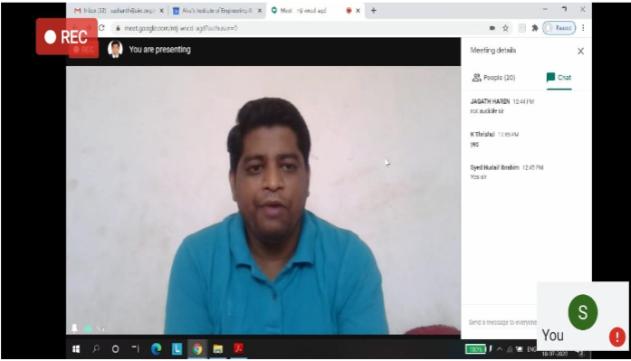

**Blockchain**

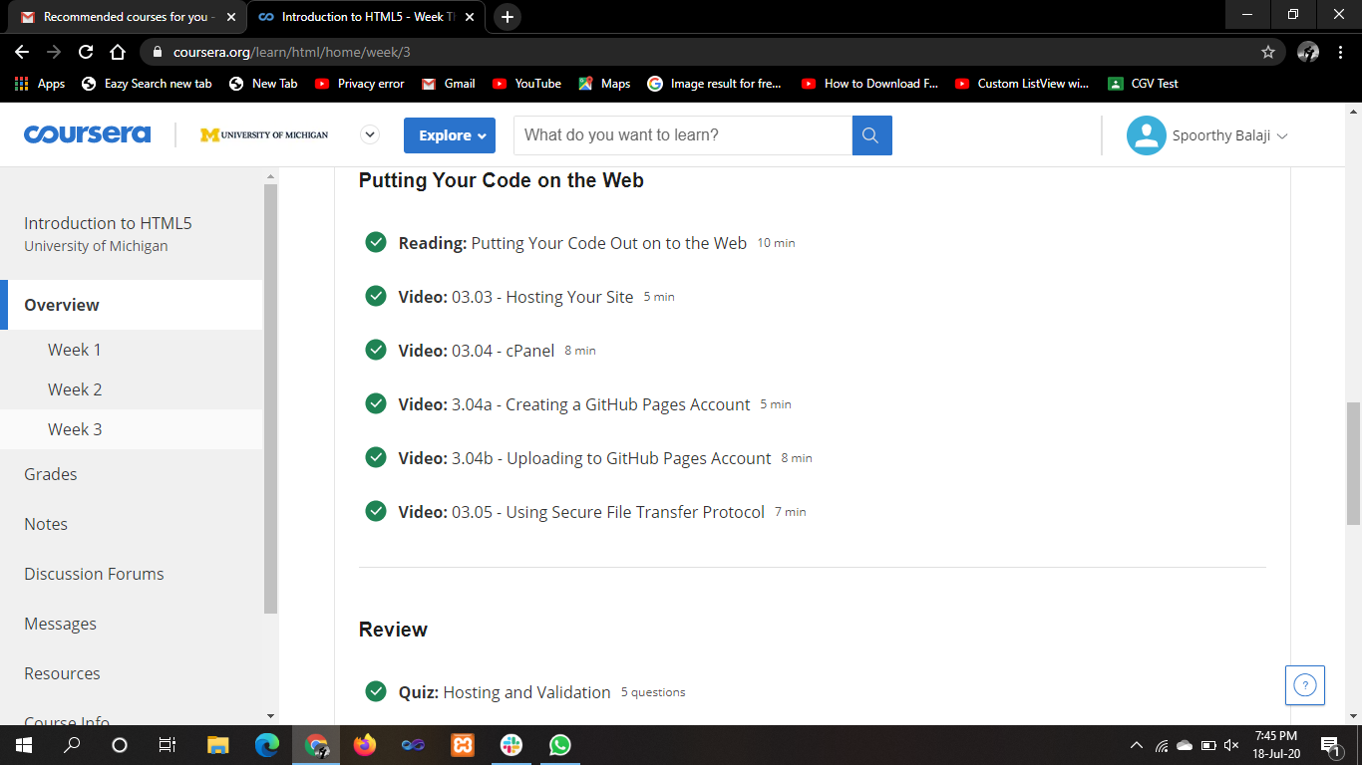

**Coding**

Python Program for Basic Euclidean algorithms

def gcd(a, b):  
   if a == 0 :  
      return b  
   return gcd(b%a, a)  
a = int(input('Enter a:'))  
b = int(input('Enter b:'))  
print("gcd of ", a , "&" , b, " is = ", gcd(a, b))